Match the book to the name of the writer.

1. 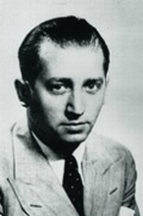 Journal
2. Mircea Eliade
3. Mihail Sebastian
4. Marin Preda
5. Max Blecher

Answer: b

1. 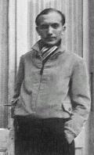 Scarred Hearts
2. Camil Petrescu
3. Vasile Voiculescu
4. Max Blecher
5. Mircea Eliade

Answer: c

1. 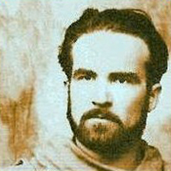 Maitreiy/Bengal Nights
2. Zaharia Stancu
3. Mircea Eliade
4. Gellu Naum
5. Eugen Barbu

Answer: b

1. 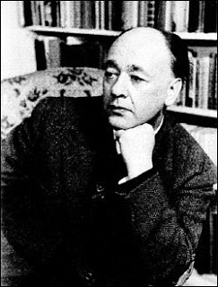 The chairs
2. Ion Luca Caragiale
3. Barbu Delavrancea
4. Eugene Ionesco
5. Mihail Sebastian

Answer: c

1.  Wasted Morning
2. Martha Bibescu
3. Hortensia Papadat Bengescu
4. Gabriela Adamesteanu
5. Elena Vacarescu

Answer: c